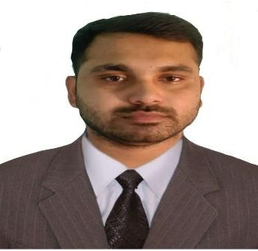SANJAYKUMAR PATRA

Objective
To work in network and hardware sector with determination and dedication to achieve organizational as well as personal goals.

Experience

Skill Joint Consultancy Pvt. Ltd
Desktop Support Engineer-L2 October 2019 till June 2022TeamcomputersPvt.Ltd

Desktop Support Engineer -L2 May2023 till April

• Configuring MS Outlook and troubleshooting the Issues
• File and Printer Sharing
• Join Domain users
• Complete the joining process of Employee by providing them Tab, Laptop, and Desktop with the proper configuration
• Work on Experience in replacement of user laptop which is lease expired and Blanco Process. iPhone Configuration for user
• Installations of Operating systems like Windows 7, Windows 8, 8.1, 10
• Applying Bit locker to particular drives
• Installing applications and troubleshoot the same
• Remote management
• Installing and configuring local printers & Network Printer and troubleshooting
• Configuring the IP address at Static way
• Asset Inventory
• Mobile configuration through MDM
• Updating and installing antivirus. Creating the local users in client machines
• Management of Active Directory (Password reset, unlock account, provide access to users, Create, and delete users)
• Call log from Vendor & coordinate with him
• Service Now/My IT Ticketing tool
• DHCP, DNS, VPN

Education:- Kamarda degree college
BA 2019
Fakir Mohan University Satyasai Engg. College
Diploma 2016
SCTE&VTSNIHTS, Kamarda
12th 2013

Skills Technical Proficiency:

- OPERATINGSYSTEM
• WIN7/8/10. Installing windows
• Backup and Format, BIOS Set Up,
• Firewall configure, Remote management, Antivirus
• Printer installation and sharing
• Third-party software installation.
• Data Recovery & Disk management.
• OUTLOOK Configuration
¬ HARDWARE
• Assembling and Disassembling and Troubleshooting
• Identification Installation & Troubleshooting of processor, memory, SMPS
¬ NETWORKING
• Network setting,
• IP configure, Network Sharing, Network Topology
• OSI Model, TCP/IP Model, Structure Cabling,
• Configuring LAN Connection
• Configure Wireless Router
• Firewall Setting

PersonalDetails
PersonalDetails
FATHER`S NAME: Kamallochan patra MOTHERS NAME : Milirani patra DATEOFBIRTH :10thJan1996
KNOWN :English, Hindi[Read, Write&Speak]

Declaration
I do hereby declare that the above-given information is true to the best of my knowledge and belief. Reference will be furnished whenever requested.

Place: SanjayKumar Patra

Date: signature

